The Rt. Hon Eric Pickles MP
Secretary of State
Department of Communities and Local Government

eric.pickles@communities.gsi.gov.uk

By Email

12th September 2014

Dear Eric Pickles,

Smithfield General Market Buildings.

Following your decision letter we have waited to write until the time limit for judicial review has passed. Now it has, we wish to state our appreciation to you and Mr Boles for an exceptionally cogent and well-worded decision letter, which sets out your views with such care, rigour and forcefulness.

We have however been somewhat dismayed by the response from the City and the owners, and indeed English Heritage, none of whom appear to attach any urgency to the matter. This is all the more serious in view of the deliberate neglect, which you identified. The building remains vulnerable as winter approaches, particularly as the roof over the canopy across the street has been removed.

The purpose of this letter is therefore to ask you to set in motion compulsory purchase proceedings on the following grounds.

1. The deliberate neglect of an important heritage asset.
2. A stated intention on the part of the owners to do nothing if they did not get the planning permission they were seeking.
3. That it is in the public interest that the Smithfield General Market Buildings should be repaired and regenerated.
We consider that an initial letter from you stating an intention to do this would have a salutary effect and might prompt action and decisions which otherwise may take months or years to achieve. As you know, we have both a viable alternative scheme, as the inspector accepted, and the investors with resources to finance it

Yours sincerely,

Marcus Binney
Executive President
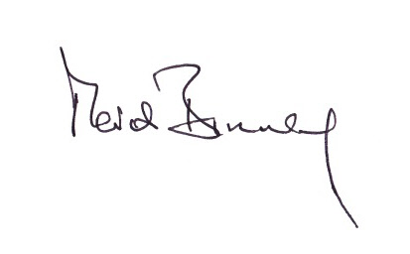

Clem Cecil
Director
